IN710 OOSD 2017 9.1 - Anonymous Delegates and Lambda Expressions
- Redo exercise 4, Practical 7.2 using lambda expressions.
- Build a simple "database" for city data. Your data class should be as shown below. Your "database" is simply a List<City>. The user inputs a country name, and you display all the cities in your database from that country.
To implement the search functionality, define an instance of the Func<T,T> system delegate, which you call when the user initiates a search. You may build the whole application in the Form class, if you wish. The only code in your application should be:
- code to populate the List<City> with seed data
- the declaration of the delegate, with its lambda expression (all in one line of code)
- The call to the delegate, passing in the user's search key and storing the result in an appropriate variable (all in one line of code)
- a foreach loop to print the results of your search to the screen.

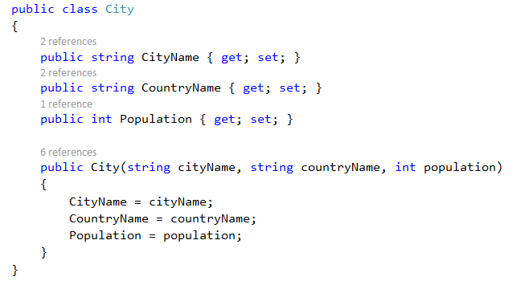

- List<T> exposes a method ForEach that accepts a lambda expression. For example, in the program from Exercise 2 above, assume that you hold all your City instances in List<City> cityList. You can then say cityList.ForEach(lambda expression goes here). The result of this command is equivalent to running a standard foreach loop over the list, and applying the lambda to each City instance.
Assume that you have suddenly discovered that the population values in your city database are all wrong and all need to be multiplied by 3 (I have no good story for why this would be so; just go with it). Add a method to your city database that first multiplies each Population value by 3, and then writes all the cities, with their new populations, to a ListBox. This method must contain exactly two lines of code, both of the format cityList.ForEach(lambda expression goes here).

